Implementation of a Linear Programming Model for ECOVAT Buffer

Hatim Mala

Hogeschool van Arnhem en Nijmegen

February 2021

# Context:

The 2019 Climate agreement (Klimaatakkoord) sets targets to reduce green-house gases emissions by 49% by 2030 and by 95% by 2050 versus 1990 levels. Furthermore, due to geological hazards, the Dutch Cabinet issued decisions in March 2018 and September 2019 that aim to end gas production from Groningen by mid‑2022. However, when considering that in 2018, natural gas accounted for 90% of residential heating demand, the challenge of the transition becomes clear. Electrification of heat (via heat pumps) would create peaks in electricity demand and further strain an already ageing electricity infrastructure. Alternative heat sources are needed.

On the other hand, implementation of the 2019 Climate Agreement measures would result in at least 70% of electricity generation coming from renewables by 2030. Given the variability of wind and solar generation, and their inability to follow the demand profile, balancing supply and demand in a grid with such a high percentage of renewables shares becomes a challenge, especially since large-scale electricity storage technologies are not yet implemented. An alternative storage medium is needed.

ECOVAT aims to address both challenges via a seasonal energy storage system. The ECOVAT is a large subterranean buffer tank filled with water. Heat and cold can be added to or extracted from the tank through conductivity via its wall. The stratification effect ensures the water inside the tank is separated into layers with different temperatures. Therefore, each layer can be charged/discharged separately.

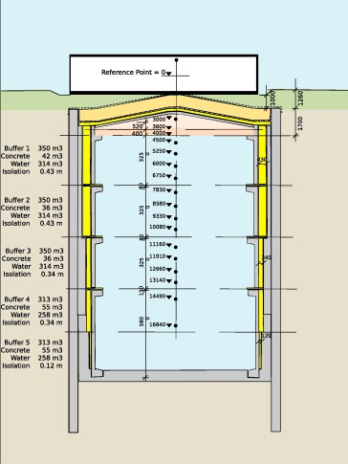

Figure 1: Layout of the ECOVAT buffer system [1]

# Problem Description

The goal of ECOVAT system is to provide seasonal thermal energy storage that can satisfy the demand all year long. This goal should be concurrently achieved while maximizing the use of renewable energy and minimizing impact on the electricity grid. These goals are not always aligned. Furthermore, given the system shown in figure (1), which shows the system having several heat storage layers and also several heat sources, Questions arise as to how to operate the system: At each moment in time, which layer should be discharged to meet the demand? Which device should be used to charge the buffer? And which layer in the buffer should the device charge? In other words, what is the optimal charge/discharge strategy that ensures meeting the demand throughout the year while minimizing operational costs and impact on the electricity grid?

The above problem description suits the structure of an optimization problem. By describing the dynamics of the ECOVAT as a set of equality and inequality constraints, and defining an objective function as the operational costs of the system, an optimization problem can be formulated The solution of the optimization problem will give the optimal charge/discharge strategy for the buffer.

# Optimization Problem Formulation:

Figure (2) shows the layout of ECOVAT model. The storage is modelled as a buffer with 5 distinct layers, each layer has a different temperature. In addition, the system has multiple heat generation devices, namely: An air/water (A/W) heat pump, 2 water/water (W/W) heat pumps, PVT panels, and a resistance heater.

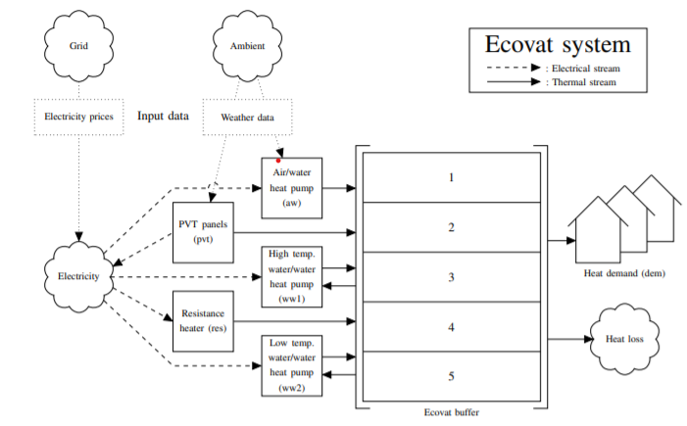

Figure 2: Layout of ECOVAT model. Source [2]

## The External Datasets:

As depicted in figure (1), the operation of ECOVAT system is affected by the weather conditions; The solar irradiation directly influences the PVT production, while the ambient temperature influences the COP of the air/water heat pump. Therefore, the linear program includes datasets of the global solar irradiation [W/m2] and ambient temperature. The data represents average hourly values for a period of one year, as provided by the KNMI measurements [3].



Similarly, a dataset representing hourly ambient temperature measurements (measured 1.5 [m] above the ground is included in the linear program.



In addition, a dataset that represents the thermal energy demand of the houses/offices connected to ECOVAT is also included in the linear program. The data represents hourly heat demand in [Wh] for space heating and DHW. For the purposes of the program, it is assumed that this demand occurs at 40 C.



Finally, since the optimization routine aims to minimize ECOVAT operation costs, a dataset of the APX electricity prices is also included in the linear program. This is hourly prices in [Euro/MWh] values as published by Tennet [4].



## Set of Constraints:

The dynamics of the ECOVAT buffer and the operation of the connected devices is described in a set of equality and inequality constraints that must be obeyed at each time step. The constraints are listed below. The elaborate mathematical formulation of the constraints is detailed in [2].

1. For every time step, any device can only be connected to a single segment.
2. For every time step, any segment can only have a single device connected to it.
3. The temperature in the buffer should not exceed a certain maximum allowed temperature.
4. At each moment of time, the temperature gradient should be preserved. i.e the temperature of a layer should be higher than the temperature of the layers below.
5. The PVT panels should be connected to a layer only if PVT output temperature is higher than the temperature in that layer.
6. An equality constraint defines the PVT output temperature as a function of solar irradiation, and input temperature.
7. The air/water heat pump uses the ambient air as heat source and one of the buffer segments as heat sink. Inequality constraints define the minimum and maximum temperatures the heat pump can supply.
8. The water/water heat pumps use one layer as a heat source and a higher layer as a heat sink (Transfer heat from a low temperature layer to a higher temperature layer). A set of inequality constraints determine if a layer is in the range of heat pump sink or source.
9. A layer can be discharged to meet the heat demand if the temperature of the layer is higher than the temperature of the demand.
10. An equality constraint defines the heat loss at each time step.
11. The temperature evolution in each layer is modelled by an equality constraint which defines the heat balance within the layer.

## The optimization variable:

The linear program attempts to find the minimum objective function without violating the constraints. To achieve that, the program manipulates the values of the binary variable:

The variable x represents the state of device d at time t with respect to layer s.

Where t is the time step

And d is the device connected to ECOVAT

And s is the segment withing ECOVAT layers

Therefore, the outcome of the optimization problem is the decision variable that determines for each time step whether a device is turned ON/OFF, and if ON, to which layer in the buffer it should be connected. In other words, the control strategy for ECOVAT devices that minimizes the operation costs.

## The Objective function:

The cost of the system C(t) at time t can be expressed by:

Where are the power ratings [W] of the devices. And is the power generated by the PVT at time t. It is assumed that the PVT generated electricity can be sold. E(t) is the APX price of electricity at time t.

The term C(t) gives an expression of the quantity to be minimized. However, this term alone doesn’t equal the objective function. For the purposes of the control strategy, another term is added that incentives the optimization program to favor charging the upper layers of the ECOVAT buffer. This is desirable from a practical point of view because only the higher temperature segments can satisfy the heat demand. This incentivizing term is expressed by:

Where K is a scaling constant, and T(t,s) is the temperature of layer s at time step t. Now, the full objective function is given by:

# Implementation

The optimization toolbox in MATLAB offers solvers for various families of optimization problems, including linear programming and mixed-integer linear programming problems. In the “Problem based” approach, the optimization problem is defined as an object. Within this object, all the components of the optimization problem are defined, namely: the constraints, the objective function, and the optimization variables. Once the definition of this object is complete, it is passed to MATLAB function ‘linprog’. The function applies the selected algorithm to to solve the optimization problem and return the results. The results include the value of the minimized objective function, the optimization variables that minimize the objective function, in addition to other diagnostic information to validate the optimization. MATLAB optimization toolbox offers two algorithms for solving linear programs: Dual simplex algorithm and Interior-point algorithm. For this study, the former algorithm is chosen. Nevertheless, both algorithms return similar minima.

# Results

## Discharge Scenario in Winter

In this scenario, the optimization problem is run over an arbitrarily selected week in winter (January 1st to January7th). It is assumed that at the start, the buffer is relatively charged, with the initial conditions:

The temperature evolution inside the buffer is shown below:



Figure : Temperature evolution inside the buffer

In addition, the control sequence for the heating devices is depicted in the figure



Figure : Control sequence of the heating devices

For context, the ambient temperature, solar irradiation, heat demand, and electricity prices are provided in the figure below:



Figure : External data for the period Jan 1st Jan 7th

## Charge Scenario in Summer

In this scenario, the optimization problem is run over an arbitrary selected Summer week (July 1st to July 7th). It is assumed that at the start, the buffer is relatively depleted, with the initial conditions:

The datasets used for evaluation of this period are depicted in the figure below:



Figure : Datastes Corresponding to period July 1st to July 7th

The temperature evolution in buffer is shown in the figure below:



Figure : Temperature Evolution inside the buffer

In addition, the figure below depicts the control sequence of the heating devices



Figure : Control sequence of the heating devices

# Summary:

* A linear programming model was implemented to obtain an optimal control strategy for ECOVAT buffer that minimizes the cost while meeting the heat demand and maintaining the stratification of the buffer.
* The dynamics of the thermal storage and the characteristics of the heating devices were expressed as a set of linear constraints.
* An objective function is chosen as the cost of operating the buffer, with additional terms representing the energy content of the buffer.
* The goal of the optimization (Optimization variables) is to find the optimal control sequence of the heating devices.
* The linear programming model was implemented in MATLAB. Two scenarios were implemented, each for a duration of one week: Discharge in a winter week (January), and charging in a Summer week (July).

# Conclusions and Recommendations:

* For the Winter discharge scenario, the results show that control strategy prioritizes discharging from the lowest possible layer (The lowest layer whose temperature is above the demand temperature). Heating devices stay off while only the PVT is occasionally used.
* For the Summer charging scenario, the results show that control sequence prioritizes charging using the heat pumps. The PVT is turned ON whenever possible, while, the resistance heater is rarely turned ON.
* **Computational effort**: For the discharge scenario, the results were obtained relatively fast. This is because since no heating device needs to be turned on, the decision of the optimizer is then limited to the task of deciding which layer should be chosen to satisfy the demand for each time step. However, for the summer charging scenario, the computational time is substantially larger, because in this scenario, extra decisions need to be made regarding which device to be used to charge which layer.
* **Constraints violations:** It can be seen form the Summer discharge scenario that the constraint of having the temperature of layer 3 strictly lower than layer 4 is slightly violated (Both temperatures approach 40 C towards the end). This is because as the size of the optimization problem becomes larger, the harder it becomes to find a feasible solution without operating close to the constraints.
* **Predictions**: The linear programming algorithm assumes perfect knowledge of the weather conditions and the electricity prices a week in advance (All the data needs to be available at the start of the simulation). In reality, this is a highly unlikely scenario, where predictions are not available for such a long period, and the accuracy of the predictions decrease with time.
* Linear programming is a useful tool to study the optimization of the storage system. However, for the above 3 reasons (Computational effort + Constraints violations + Prediciton accuracy), it is not recommended as an “on-line” control strategy for the actual system. Instead, a shorter time horizon should be used. This will ensure that the computational time remains feasible, the constraints are strictly met, and from a practical point of view, it ensures that the optimization is based on accurate datasets.
* Alternatively, a model-predictive control (MPC) strategy can be investigated. MPC has been used in industry since the 80s. The advantage MPC has over linear programming is that due to the feedback structure, MPC has the ability to adapt the control signals based on the deviations of the predicted data/model from the actual values.

# Bibliography

|  |  |
| --- | --- |
| [1] | J. L. F. D. R. W. M. B. D. Schutter, "A 1-dimensional continuous and smooth model for thermally stratified storage tanks including mixing and buoyancy," *Applied Energy,* 2019. |
| [2] | G. J. H. d. G. G. J. M. S. a. J. L. Hurink, "An Integer Linear Programming Model for an ECOVAT buffer," *Energies,* 2016. |
| [3] | KNMI, "KNMI data platform," KNMI, [Online]. Available: https://dataplatform.knmi.nl/open-data-info/index.html. |
| [4] | Tennet, "System and Transmission Data," Tennet, [Online]. Available: https://www.tennet.org/english/operational_management/export_data.aspx. |